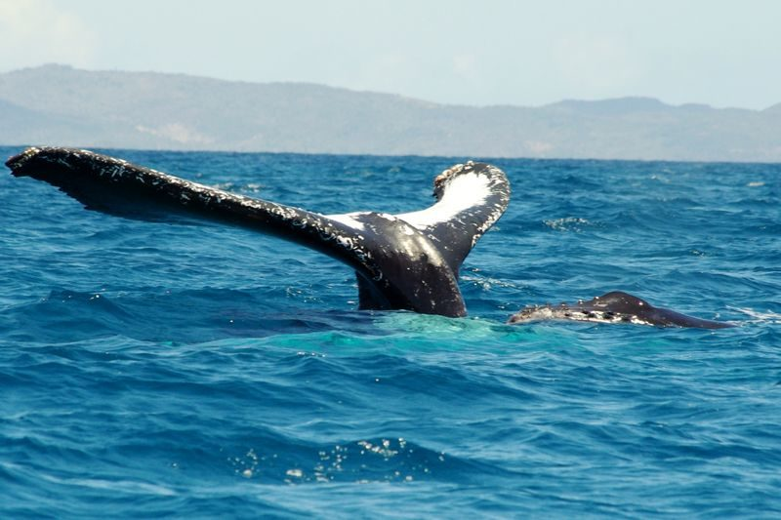
IFATY TULEAR
Less well-publicized than Sainte Marie for whale watching, Ifaty is nevertheless the meeting place for whales from June to September. Humpback whales leave the cold waters of Antarctica to mate in the warmer waters of the Mozambique Channel. The whales will only leave the area when the calves are strong enough to face the cold. It is a relatively expensive activity (between 35 and 45 € per adult). Weather conditions will play an important role in the success of the trip. But when the weather is favorable, you have a good boat (avoid going by pirogue ^ ^) and a good pilot, you will then attend a magical show! Allow 3 hours for the departure with a departure at 8 o'clock. Tides can be very important during the new or full moon.

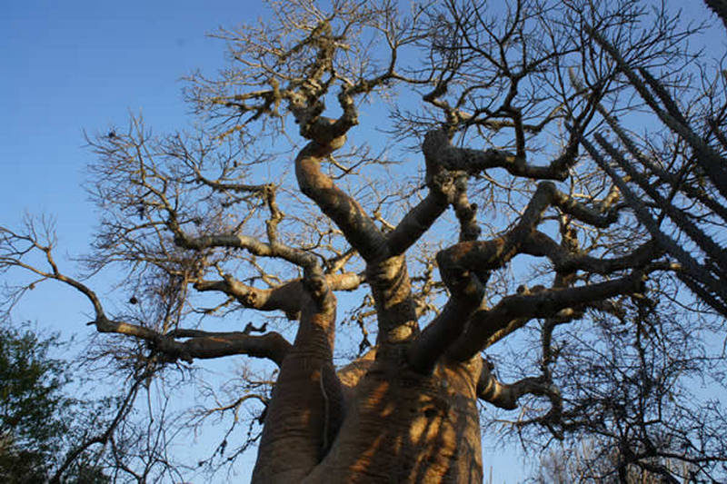
IFATY TULEAR

Visite du Parc de Reniala : It allows to observe many species that live in the Malagasy. The duration of this ballad can be very variable. It all depends on what you want to see. The classic ballad is largely <SARETY > and will be devoted to trees and medicinal plants.



Vez'tival in TULEAR:
At the end of October, you will be honored with art and culture with the Vez'tival. You can enjoy the sun of Tulear while living a week full of activities! On the program: fair, shows, concerts, conferences with recognized partners, choir, exhibitions, canoe races, beach rugby, quad rides and even activities for children. The vez'tival was created to be a unifying event around common values ​​such as hygiene awareness. This festival also allows you to rediscover the wonders of this region including the diversity of landscapes, the 6000 km long coral reef and the incredible fauna and flora.

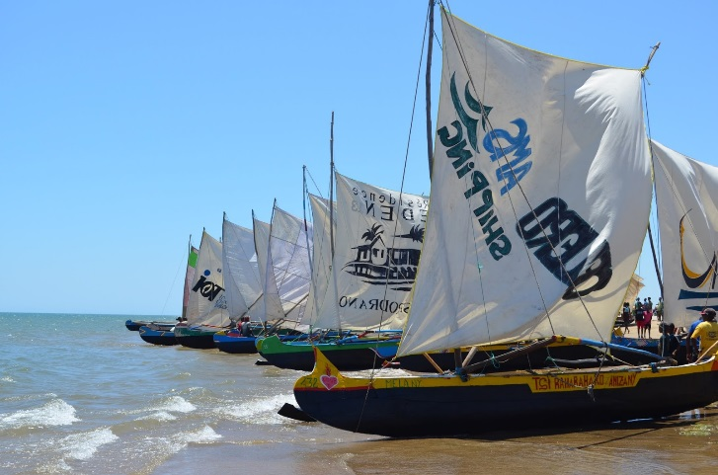
canoe races

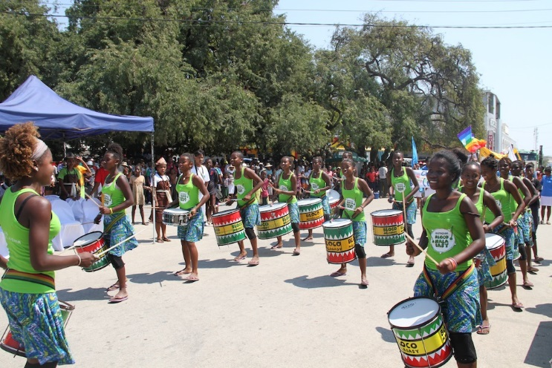
local music



- To discover a preserved nature
The province of Tulear is a concentrate of natural wealth preserved to perfection. You will discover at the same time the wild aspect of its canyons (like those of the National Park of Isalo), the mystery of its baobab forests and the fullness of its desert of sand.

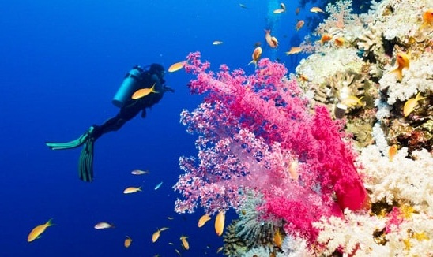

Famous for its proximity to the famous reef barrier, Tulear can offer you superb dives!

HOTEL TULEAR:
- Villa Claire:
Set on the seafront in Toliara, Villa Claire offers accommodation with a garden, a year-round outdoor pool, sea views, a private beach area, barbecue facilities and free Wi-Fi.
This villa features 3 bedrooms, a kitchen with an oven, a washing machine, a bathroom, and a flat-screen TV with satellite channels.The reception staff speak French, English, Italian and Dutch. He will be happy to provide you with information about the area.Villa Claire has an indoor pool and a bicycle rental service.

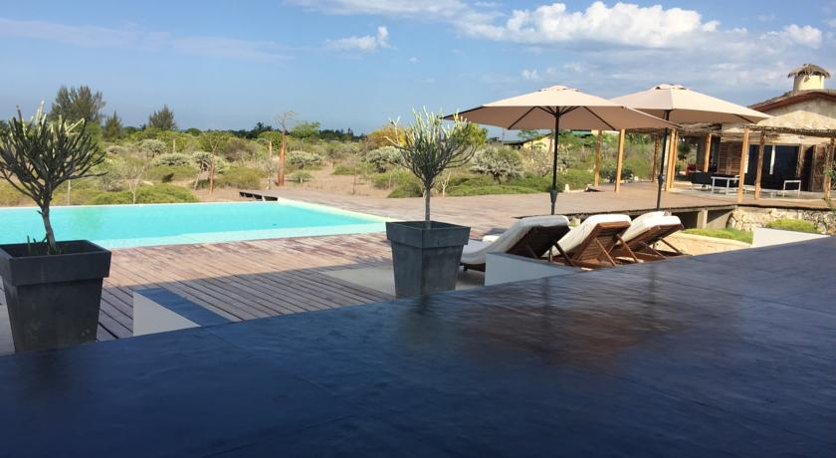

ANAKAO TULEAR
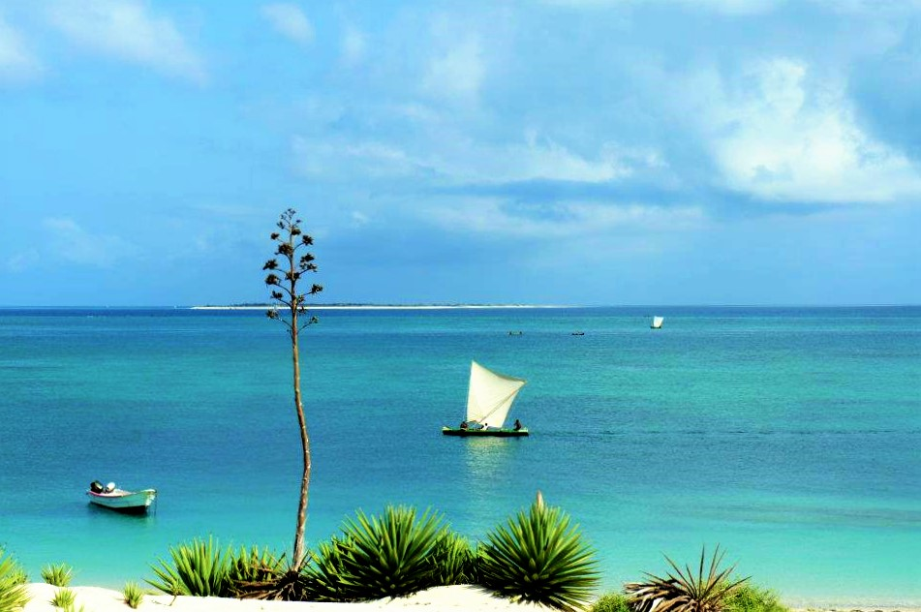
TOURIST ACTIVITY
WE CAN MAKE :
- Diving and windsurfing in Anakao
- Visit the national park of Tsimanampetsotsa where we can see turtle an endemic species
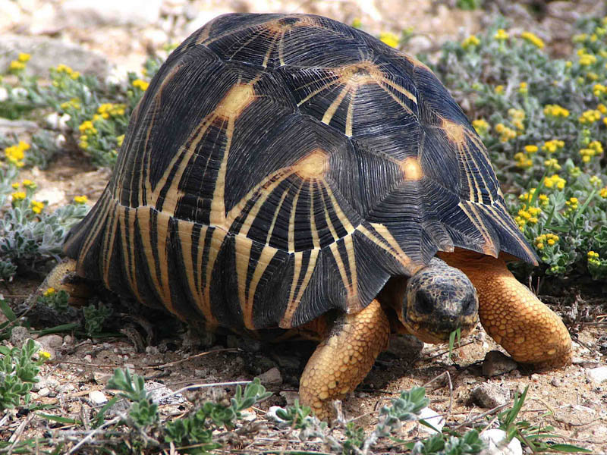

POPULAR HOTEL IN ANAKAO:
- MADA SURF LODGE:
Located in Anakao, Mada Surf Lodge offers a garden, a terrace, a shared lounge, a 24-hour front desk and a restaurant. Free private parking is available on site. Free WiFi is available.

